Practical 14 — Admin Dashboard, RBAC, Dynamic Menu, and Audit Log

Ai
To give administrators live statistics, strict role separation, role-shaped navigation and an appendonly audit trail of every sensitive action.

Theory
Dashboards must show live counts, never cached claims; roles must be enforced on the server before output; and every mutation must leave a who, what and when row that never records secrets.
- Dashboard cards run live count queries with a newest-registrations join and a recent-activity preview.
- Roles form a ladder: students see their own areas, faculty add student and event management, admins add dashboard statistics and the audit viewer.
- Navigation renders per role but each page re-checks the role on the server, so hidden links alone grant nothing.
- An audit helper logs successful student and event writes plus admin sign-ins with actor, entity and timestamp, explicitly excluding passwords, hashes and tokens.
- The audit viewer offers filters and pagination with injection-safe and bad-date-safe handling and a helpful empty state.

Procedure
- Built the admin dashboard page of about 15 KB with live count cards, registration join and activity preview.
- Built the audit viewer of about 13 KB with filters, pagination and empty states.
- Added the audit helper, role-aware navigation include and audit migration promoting the admin role.
- Extended the endpoint and management pages to write audit rows on every successful mutation and admin sign-in.
- Inspected dashboard, viewer, helper, navigation and migration on disk; live sign-in and mutation logging were not re-run here without a server.

Screenshots

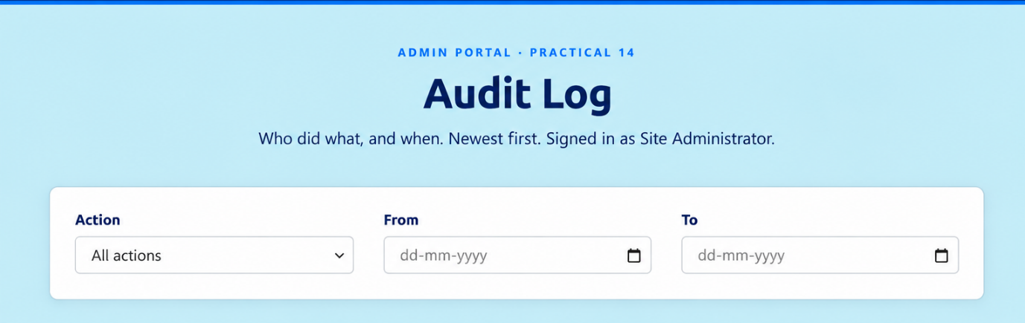

Figure 14.2 — Audit Log running (project screenshot).
GitHub Repository Link
Practical repository : https://github.com/Rkpatel34/StudentHub/tree/main/studenthub

Conclusion
Practical 14 made power accountable: admins see the truth live, roles hold on the server, and every change leaves a trace.

